1. 測試內容：

測試L2 Group Entry with type “SELECT”是否正確運行。

1. 測試環境架構：

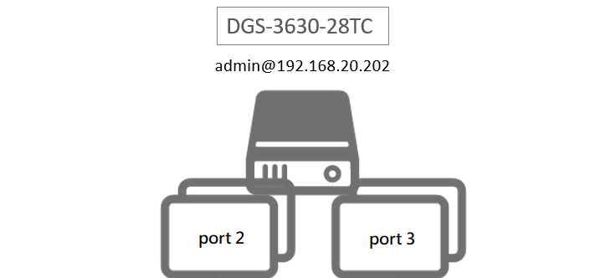

1. 測試環境組態：

* SDN controller: ONOS 1.15.1
* Switch: DGS-3630
* Apps:

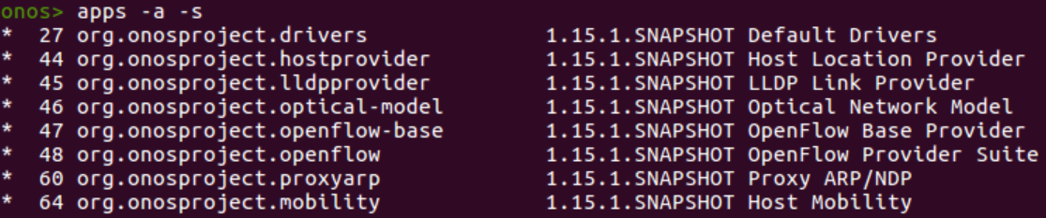

1. 使用之JSON文件：
   * 根據Appendix - OpenFlow Object Details.pdf，建立SELECT group需要使用下列五項group entries：

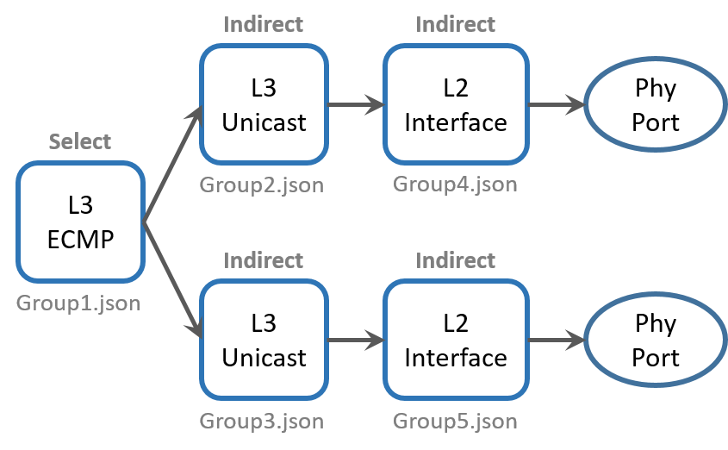

* + L2 interface 1 (group4.json)

|  |
| --- |
| {  "type":"INDIRECT",  "appCookie":"0x10002",  "groupId":"65538",  "buckets":[  {  "treatment":{  "instructions":[  {  "type":"OUTPUT",  "port":"2"  }  ]  }  }  ]  } |

* + L2 interface 2 (group5.json)

|  |
| --- |
| {  "type":"INDIRECT",  "appCookie":"0x10003",  "groupId":"65539",  "buckets":[  {  "treatment":{  "instructions":[  {  "type":"OUTPUT",  "port":"3"  }  ]  }  }  ]  } |

* + L3 Unicast 1 (group2.json)

|  |
| --- |
| {  "type":"INDIRECT",  "appCookie":"0x20010002",  "groupId":"536936450",  "buckets":[  {  "treatment":{  "instructions":[  {  "type":"GROUP",  "groupId":"65538"  }  ]  }  }  ]  } |

* + L3 Unicast 2 (group3.json)

|  |
| --- |
| {  "type":"INDIRECT",  "appCookie":"0x20010003",  "groupId":"536936451",  "buckets":[  {  "treatment":{  "instructions":[  {  "type":"GROUP",  "groupId":"65539"  }  ]  }  }  ]  } |

* + L3 ECMP (group1.json)

|  |
| --- |
| {  "type":"SELECT",  "appCookie":"0x70010000",  "groupId":"1879113728",  "buckets":[  {  "treatment":{  "instructions":[  {  "type":"GROUP",  "groupId":"536936450"  }  ]  },  "weight":"1"  },  {  "treatment":{  "instructions":[  {  "type":"GROUP",  "groupId":"536936451"  }  ]  },  "weight":"1"  }  ]  } |

1. 測試步驟：

* 使用以下指令倒序安裝group rules：

|  |
| --- |
| for i in {5..1}; do curl –user onos:rocks –X POST –H “Content-type: application/json” -d @group$i.json http://localhost:8181/onos/v1/groups/of:000078321bdf7600; done |

* 查看ONOS GUI Group view

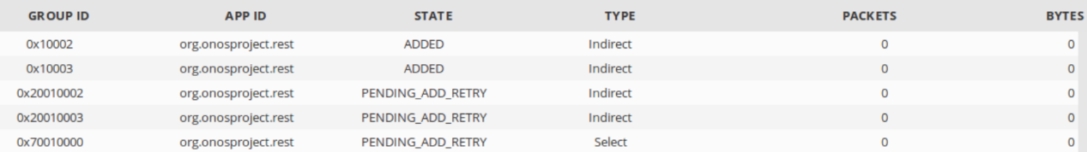

* 透過switch CLI查看switch CLI

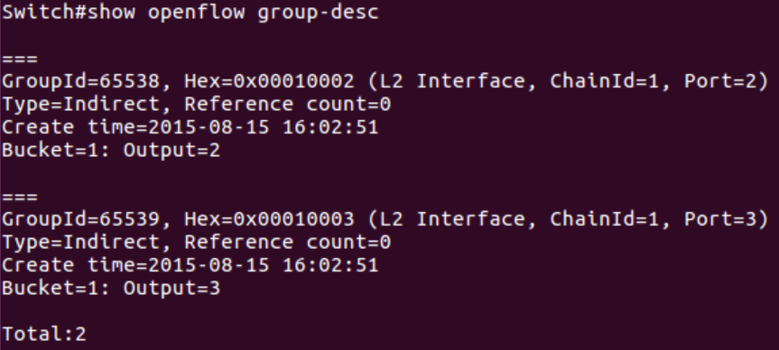

可以發現SELECT group (L3 ECMP)，以及它串接的L3 Unicast都沒有成功安裝。

1. 測試結果：

L2 Group Entry with type “SELECT”無法正確運行。